<https://itsals.visualstudio.com/Crew/_testManagement/mine>

Test Plans:

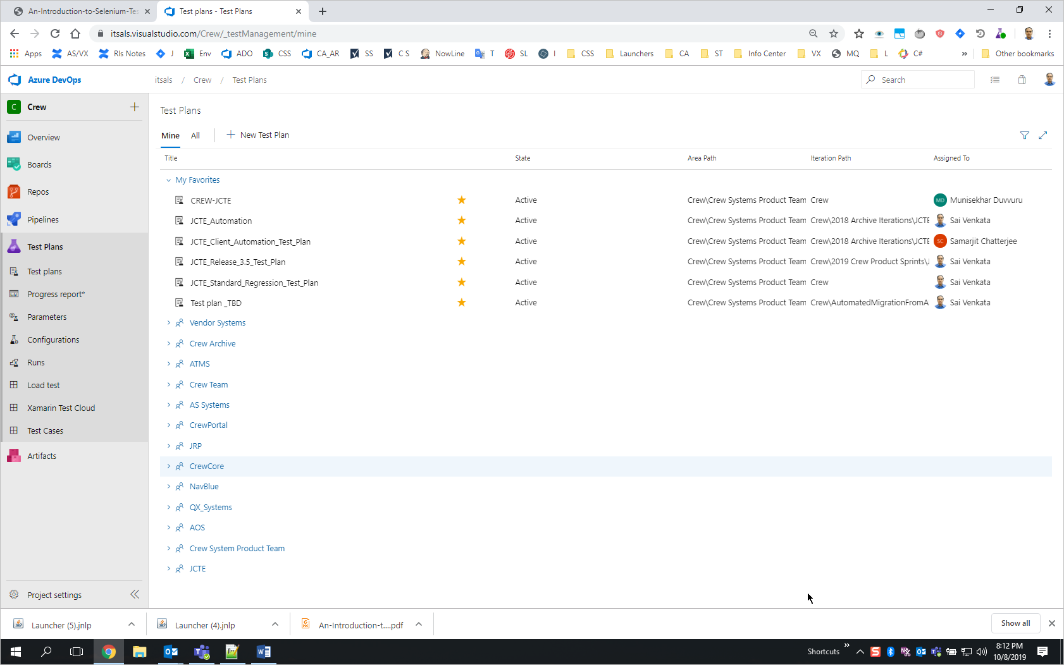

Click on All

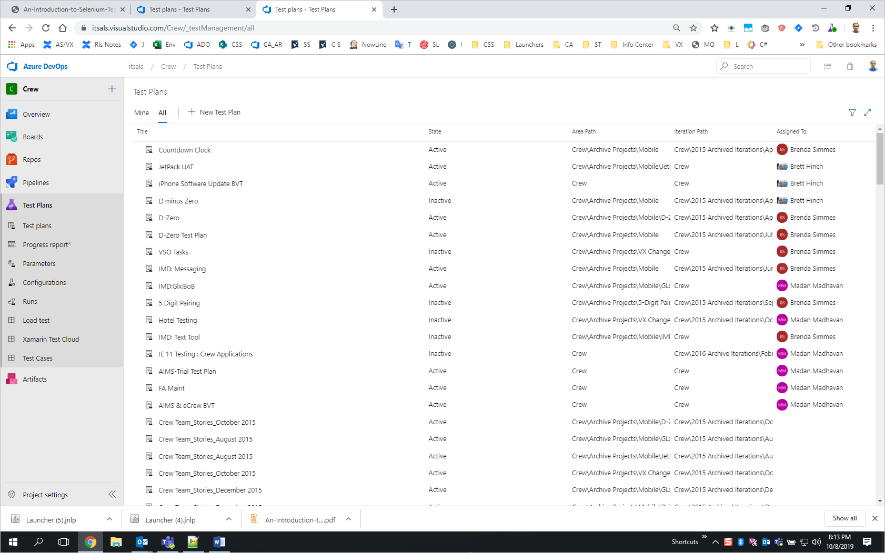

Click on filter on right side:

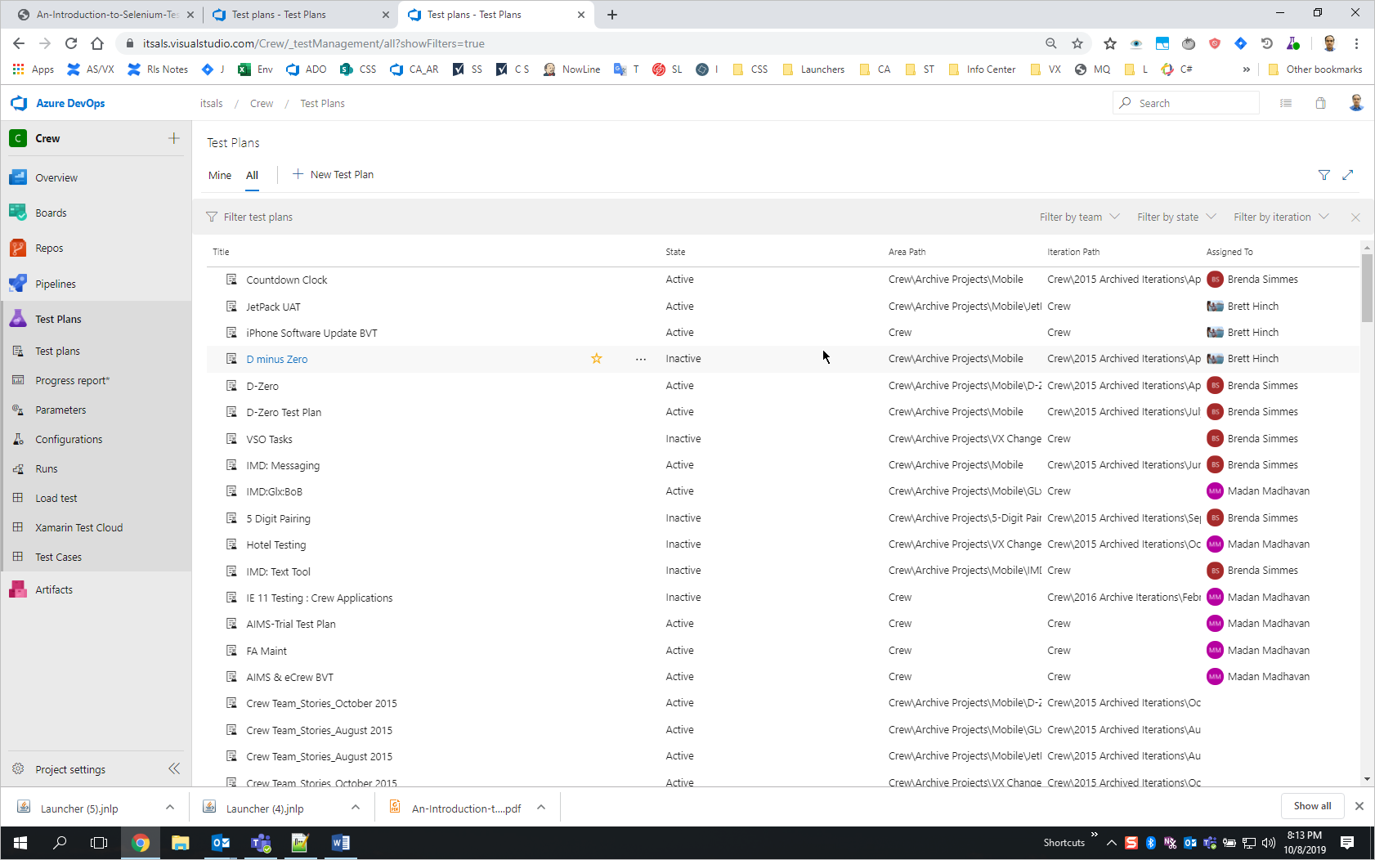

Type in standard in the filter box

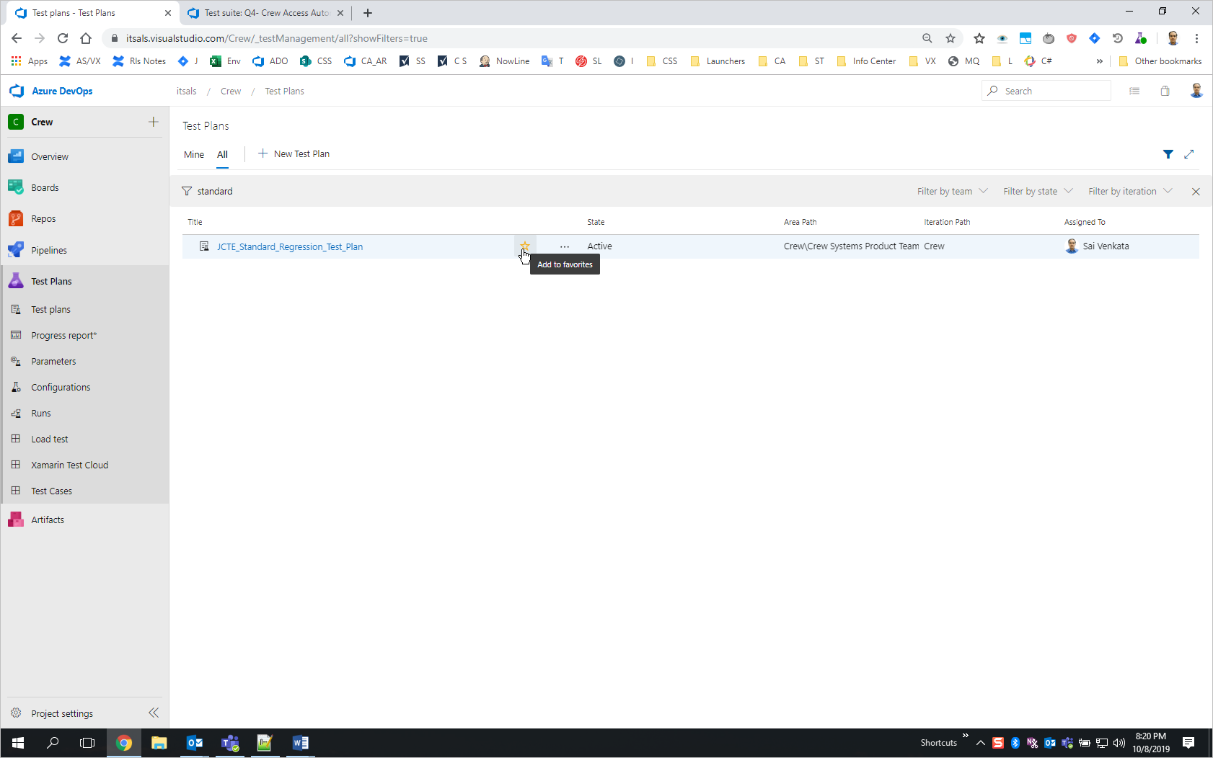

Click on start to Add to favorites.

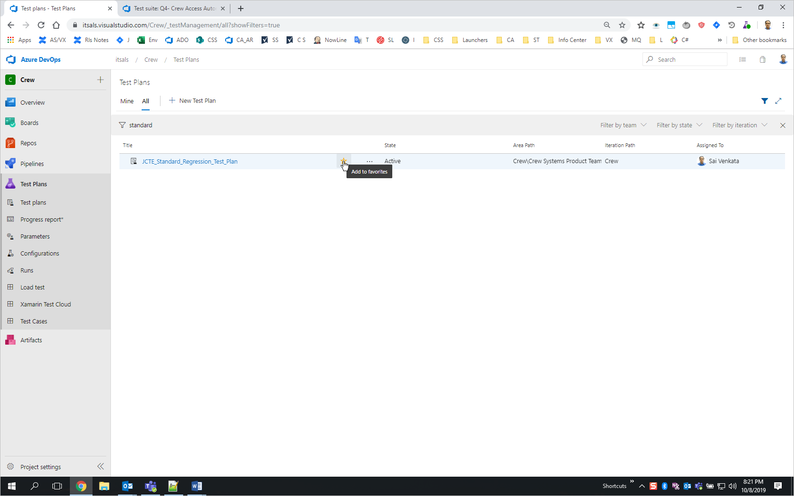

Then click on the plan:

<https://itsals.visualstudio.com/Crew/_testManagement?planId=385620>

should see the automation artifacts: As you do, please have the artifacts added here accordingly for client (including interfaces) and crew access.

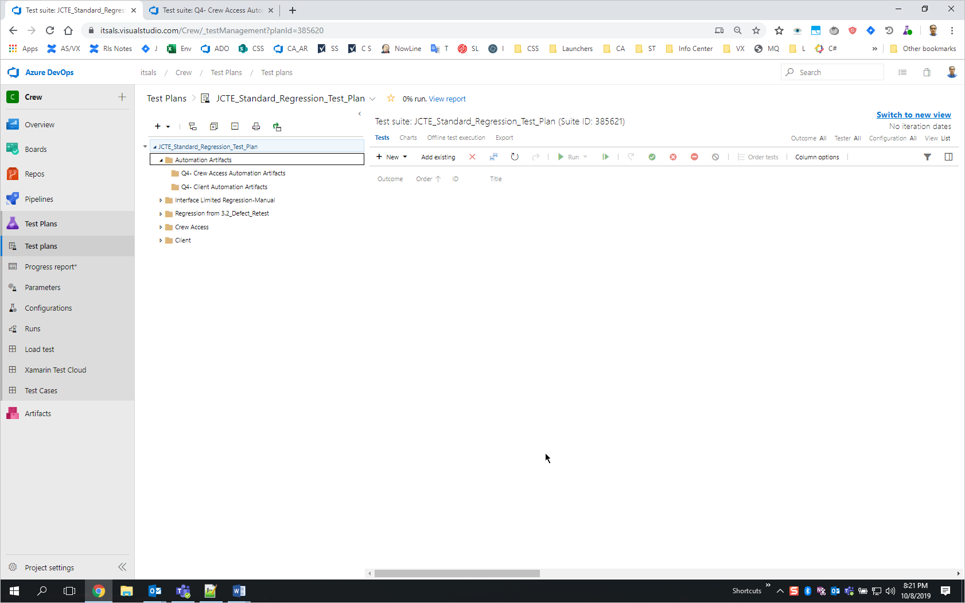

Please let us know for any questions.